Working with Taxon Names

Working with Taxon Names 1
The Taxon Explorer 2
Viewing the classification: the Contents tab 2
Taxon ranks 3
Valid, available and literature names 5
How names are displayed in the Taxon Explorer 5
Display order of names 6
Adding, updating and deleting taxa 6
Adding taxa 6
Updating names 7
Deleting taxa 7
Modifying the classification 8
Changing the rank of a taxon and combining taxa 8
Drops that fail 8
Deleting levels from the classification 9
Locating taxon names: the Find tab 9
Managing commonly used taxa and sets of taxa: the Favorites tab 10
Transferring taxa to Favorites 10
Organising Favorites using Favorites Groups 10
Removing items and groups from Favorites 10
Controlling access to taxon information 11
The User Manager 11
Taxon Permissions 11
Predefined taxon reports 12
Material for Taxon Report 12
Sites for Taxon Report 13
Statistics 13
Checklist Report 13
Selected Taxa List Report 14
Taxon Explorer commands 15
File menu 15
Edit menu 15

Working with Taxon Names

Taxa form the cornerstone of a BioLink database. They are one of the primary ways information is organised and accessed, and most items stored and managed within BioLink are associated with taxon names in one way or another. For example, specimens (or material, as they are known within BioLink) are almost always identified and therefore are assigned to a taxon name. Similarly, literature is generally associated with taxa in the form of biological or taxonomic references, multimedia can include images or sounds of a specific species, and observations are made of a given taxon.
While taxa are important, their management can be a complex and time consuming task. New taxa are constantly being added, classifications always seem to be in a state of flux and existing species are being synonymised or having their names changed for nomenclatural reasons.
Because of the importance and complexity of taxa (and their nomenclature and classification), BioLink provides a special tool, the Taxon Explorer, to graphically display taxon names together with their classification. This Explorer provides, in a single window, all of the facilities necessary to add, combine and remove taxa, modify their names and change their position in the classification. The Explorer also includes a search facility for locating name(s) and a way to manage commonly used names and sets of names. These facilities greatly simplify the task of managing taxon names resulting in significant time savings and fewer errors, thus contributing to generally higher data quality.

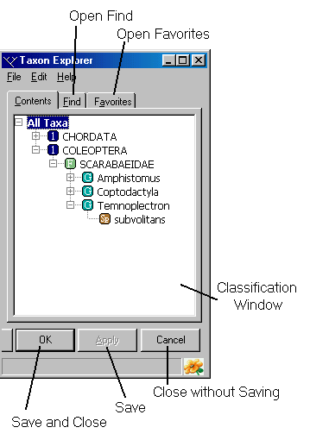
The Taxon Explorer
The Taxon Explorer graphically displays the names of all taxa held in a BioLink database, together with their classification. To start the Taxon Explorer, press the Taxa button on the main BioLink toolbar.
The Explorer has three tabs near its top. The Contents tab contains a complete, hierarchical listing of all taxa in the database based on their current classification. The Find tab is used to locate names within the database, and can search using either complete or partial names. The third tab, Favorites, is used to organise commonly used names and sets of names. This tab helps reduce complexity and speeds access to names.

Viewing the classification: the Contents tab
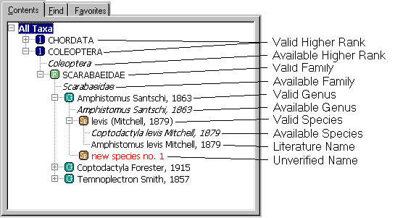
The Contents tab is the starting point when using the Taxon Explorer. This tab contains the Classification Window that displays a hierarchical list of all taxa in the database. When first opened, this window shows only the top-most or highest ranking taxa in the database (named ‘All Taxa’). Clicking the small plus symbol (+) before the taxon name expands the tree and shows all children or next-level taxa found below the selected taxon. This process can be repeated until all taxa in a branch are displayed. To expand an entire branch including all of its children and their children at once, select the taxon, click the right mouse button or open the Edit menu and select the Expand Full Branch command. Once expanded, clicking on the minus symbol (–) before its name can collapse a branch. This will hide all of its children and their children as well. If this branch is later re-expanded it will be displayed in the same way it was when it was collapsed. This means that any children that were expanded will automatically be expanded, while any that were collapsed will remain collapsed.

Taxon ranks
BioLink supports any number of taxonomic ranks. These ranks are treated hierarchically and BioLink checks to ensure this hierarchy is properly maintained when new taxa are added or changes are made to the classification. (Note, however, that the Import Wizard relaxes this requirement and will allow the creation of ‘improper’ hierarchies. See Import Wizard for further details.) Following is a complete list of the ranks supported by BioLink. This list is in hierarchical order and shows restrictions or dependencies between ranks. While the rules for the use of each type of name may appear complex, BioLink will automatically enforce these rules and will give messages if improper actions are attempted. Because of the differences between animal and plant nomenclature, they are treated separately.

Animal ranks
Rank | Children
Kingdom | Subkingdom, Phylum
Subkingdom | Phylum
Phylum | Subphylum, Superclass, Class
Subphylum | Superclass, Class
Superclass | Class
Class | Subclass, Cohort, Superorder, Order
Subclass | Infraclass, Cohort, Superorder, Order
Infraclass | Cohort, Superorder, Order
Cohort | Superorder, Order
Superorder | Order
Order | Suborder, Superfamily, Family
Suborder | Infraorder, Superfamily, Family
Infraorder | Superfamily, Family
Superfamily | Family
Family | Subfamily, Genus
Subfamily | Supertribe, Tribe, Genus
Supertribe | Tribe, Genus
Tribe | Subtribe, Genus
Subtribe | Genus
Genus | Subgenus, Species Group, Species
Subgenus | Species Group, Species
Species Group | Species
Species | Subspecies
Subspecies | n/a
Plant ranks
Rank | Children
Kingdom | Subkingdom, Phylum
Subkingdom | Phylum
Phylum | Subphylum, Superclass, Class
Subphylum | Superclass, Class
Superclass | Class
Class | Subclass, Cohort, Superorder, Order
Subclass | Infraclass, Cohort, Superorder, Order
Infraclass | Cohort, Superorder, Order
Cohort | Superorder, Order
Superorder | Order
Order | Suborder, Superfamily, Family
Suborder | Infraorder, Superfamily, Family
Infraorder | Superfamily, Family
Superfamily | Family
Family | Subfamily, Genus
Subfamily | Supertribe, Tribe, Genus
Supertribe | Tribe, Genus
Tribe | Subtribe, Genus
Subtribe | Genus
Genus | Subgenus, Section, Species Group, Species
Subgenus | Section, Species Group, Species
Section | Subsection, Series, Species
Subsection | Series, Species Group, Species
Series | Subseries, Species Groups, Species
Subseries | Species Group, Species
Species Group | Species
Species | Subspecies
Subspecies | Variety, Form
Variety | Subvariety, Form
Subvariety | Form
Form | Subform
Subform | n/a

In addition to supporting taxa at the above ranks, BioLink supports species inquirenda, incertae sedis, unplaced taxa and unranked taxa. The first two of these are defined in the Zoological Code while the third is used primarily to hold taxa who’s current placement in the hierarchy is unknown. Unranked taxa can be used as “place holders” while making changes to a classification that would not be possible if the strict hierarchy was followed. The rank of an item can be changed using the Change Rank command on the Edit menu.
Advanced Note: The ranks supported by BioLink, along with the rules defining the relationships between ranks, are defined in tables held within a BioLink database. By changing these tables the ranks and hierarchy supported by the database can be changed. BioLink does not currently provide tools for changing these tables directly as the default ranks and hierarchy provided with BioLink will meet most needs. If changes are required they will need to be made directly in the database using an SQL-based tool such as Microsoft’s SQLServer.

Valid, available and literature names
BioLink makes a distinction between valid and available names (in zoology), accepted names and basionyms (in botany) and literature names (in both). The reason for this distinction is that different information is associated with each type of name. For example, valid and accepted names can have information on distribution, multimedia, literature, common names, material and storage location; available names have literature and type data; and literature names have only literature references. BioLink defines these types of names as follows:
Zoology
Valid Name. The correct, current name of a taxon. This is the name by which a taxon is currently known.
Available Name. A name that is regulated by, or valid under the Code. This is the name as it was originally proposed.
Botany
Accepted Name. The correct, current name of a taxon. This is the name by which a taxon is currently known.
Basionym. A name that is regulated by or valid under the Code. This is the name as it was originally proposed.
Both
Literature Name. The use or appearance of a name that differs from the way it was originally proposed or is currently used.
To explain these differences another way, the valid or accepted name is the name that is currently used for a taxon. This is the name as it would appear in a publication or used when making an identification. Any given taxon will have only a single valid or accepted name at any given time (BioLink does not support multiple classifications). The available name or basionym is the name as it was originally proposed. Any given taxon will have at least one available name or basionym (the one the valid name is based on) and any number of additional available names (representing such things as junior synonyms and junior homonyms that have been replaced). Literature names (also called valid names in botany, but not used here to reduce the confusion with the same term used in zoology for a different type of name) are names that have been used in the past and that differ from valid and available names. A taxon can have any number of literature names. The most common types of literature names are previous generic combinations and misspellings. Unavailable names (those not regulated or valid under the Code) can be treated as literature names.
Note that available names can be converted to literature names, and literature names to available names, using the Convert to Literature Name and Convert to Available Name commands from the Taxon Explorer. To convert a name, select it in the Explorer, click the right mouse button and select the appropriate command.

How names are displayed in the Taxon Explorer
Each taxon is represented by a single valid name and this name can be at any rank. In the Explorer, these names are in roman (non-italic) font and are preceded by an icon indicating their rank. Taxa of the same rank and under the same parent are displayed directly above and below each other (that is, at the same level in the tree). However, the same rank under different parents may be at different levels in the tree. This is because many ranks are optional and the number of levels or ranks in any branch can (and generally will) vary among branches.
Available names are always placed under (as children of) valid names. They are in italics and are not preceded by an icon. Literature names are similar except they are in roman (non-italic) font.
Valid names can have valid, available and literature names as children, while available and literature names do not have children. When clicking on the plus symbol before a valid name expands the tree, all of its children are displayed. To expand the tree further, continue to click valid children until the branch is fully displayed, or alternately select the name and open the Edit menu or click the right mouse button and select the Expand Full Branch command. Note that this command should be used with caution when working with large datasets. Expanding a higher order taxon containing several thousand species (with several thousand available names) can be quite time consuming and this command cannot be aborted once started.
Unranked names are treated in a similar manner to valid names. They can be placed anywhere in the classification and can be identified by their question mark (‘?’) icon.
In some cases it will be necessary to work with names that represent undescribed taxa. BioLink allows these names to be flagged as ‘unverified’. Unverified names can be at any rank and of any type. In the Explorer these names are displayed in red. Existing names can easily be toggled between verified and unverified using the Taxon Properties window (see below).

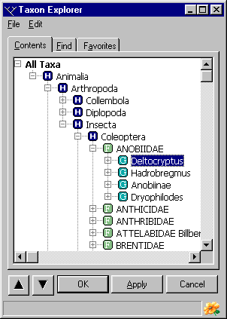
Display order of names
The Taxon Explorer can display names in two orders: alphabetically and user-defined (or ‘random’). When alphabetic sorting is required, select the By Name command from the Sort command on the Edit menu. Names, including newly added names, will automatically be sorted and displayed in alphabetic order.
In contrast to sorting by name, it is sometimes desirable to display taxa in a user-specified order. This may be the case when closely related taxa need to be grouped together, or taxa need to be listed in a phylogenetic sequence. To allow a specific order to be specified, select the By Manual Order command from the Sort command on the Edit menu. When this option is active, a pair of arrow buttons will appear on the Explorer and the Increase in Order and Decrease in Order commands on the Sort command of the Edit menu will be available. These buttons and commands are used to move the selected taxon relative to others of the same rank. The Up Arrow button and Decrease in Order command will move a name higher or upwards in the list while the Down Arrow button and Increase in Order command will move the name lower or downwards in the list. When initially added, new names will be placed at the top of the list and will need to be manually moved to their correct positions.
The method used to display names can be switched between these two options at any time without affecting or losing the other sort order.

Adding, updating and deleting taxa

Adding taxa
New taxon names are added directly in the Taxon Explorer. To add a new name select the parent of the new name (the taxon to which the new name belongs) and open the Edit menu or click the right mouse button. Select the Add Taxa command and then select the type or rank of the new taxon to be added from the menu. This will add a new item to the Explorer. Enter the name, author and year for the new taxon (replacing the default name automatically entered by BioLink) and press Enter. Pressing the Apply button near the bottom of the Explorer will save the newly added taxon to the database.
If the new name is being added to a taxon which already has children of another rank to that being added, a new Unplaced item will be created and all existing children transferred to it. These children will then need to be moved from Unplaced to their proper positions using drag and drop. For example, if a family containing genera has a subfamily added, an additional Unplaced subfamily will automatically be created and all of the family’s genera transferred to it. Additional subfamilies can then be added to the family and the genera distributed among these as required using drag and drop. If all genera can be placed within subfamilies, the Unplaced subfamily can be deleted when it no longer contains children. This process applies in cases where any optional rank is added to a parent containing children.

Updating names
Internally, BioLink stores the name or epithet of a taxon separately from its author and year of publication. BioLink also stores the rank of the taxon and an indication of a changed combination for species-rank taxa, as well as whether or not the name is verified. By storing these elements separately, BioLink can more easily validate names and dates, can control the presence of parentheses around author’s names and can provide more options when generating reports (such as including or excluding author and/or year from taxon names).
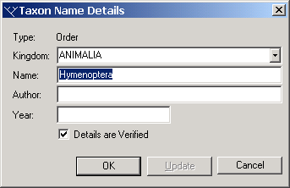
This separate storage of elements presents a problem when adding new taxon names directly to the Taxon Explorer as outlined above. The problem is that the name is being entered as a single long string that must be broken into components by BioLink before it can be stored. BioLink will attempt to break the entered name into its components, and can generally do this correctly for ‘standard’ names that consist of a single taxon name, an author and a year. It will even set the changed combination flag correctly if the author and year are in parentheses. However, BioLink may get confused with non-standard or uncommon situations. For example, if the name was established by two (or more) authors, BioLink may place the first author(s) as part of the taxon name rather than treating it/them as authors. Because of the highly variable way names, or names + authors, or names + authors + years can be entered, it is difficult for BioLink to always determine the components correctly.
To check how names entered on the Taxon Explorer have been interpreted, BioLink provides a Taxon Name Properties window. This window can be used to correct misinterpretations made by BioLink, to change or update a name or add information not originally entered and to set the verified status. To open this window select a name in the Taxon Explorer, open the Edit menu or click the right mouse button and select the Taxon Name Properties command. Modify the information as required and press the OK or Apply button to transfer changes to the Explorer, or the Cancel button to abandon modifications and return to the previous values. To save changes to the database, press the OK or Apply buttons on the Explorer. Note that for available names, the status of the name can also be entered using this window. An additional field, Name Status, will be displayed where this information can be recorded.
Names can also be changed directly on the Taxon Explorer without using the Taxon Name Properties window. This is the preferred method if changes are minor, for example updating the spelling of a name or adding the author and/or year. To modify a name directly in the Explorer, open the menu as above and select the Rename command. Edit the name as required and press Enter to save changes. Pressing the OK or Apply button of the Explorer will then save these changes to the database.
It is advisable to check names in the Taxon Name Properties window after they have been added or modified. This will ensure they are being interpreted correctly by BioLink. This is more important initially, but may become less important once the rules used by BioLink to decipher names are understood. With practice, most names can be entered and modified directly in the Explorer in a way that BioLink can interpret without errors.

Deleting taxa
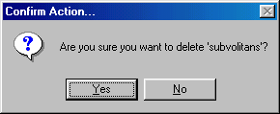
Taxa are deleted using the Taxon Explorer. Deleting a taxon will not only delete the taxon itself, but also all of its children and their children. In addition, all associated information will be deleted, including such things as literature references and common names. Also, any material identified as belonging to the deleted taxon will have its identification cleared so that it becomes unidentified. Once a taxon has been deleted and the change saved to the database, there is no way to recover any of this information—so be careful!
To delete a taxon (or several taxa), first select the item(s), then either open the Edit menu or click the right mouse button and select the Delete command. Alternately, the Delete key on the keyboard can be used. A message box will ask if you are sure you want to delete the taxon. Press Yes to delete the name(s) or press No to abandon the delete operation. If taxa were deleted pressing the OK or Apply button on the Explorer will save the changes to the database, or pressing Cancel will loose this and other unsaved changes.
For details of deleting a rank from the hierarchy but leaving that rank’s children (for example, to remove subfamilies but leave genera) see Deleting Levels from the Classification below.

Modifying the classification
Modifications to the classification are completed directly in the Taxon Explorer. For example, changing the generic placement of a species is accomplished using drag and drop to move it from its current position to its new position. Only appropriate changes will be allowed, with inappropriate attempts (those that would result in an inappropriate hierarchy or invalid parent-child relationships) resulting in warning messages being displayed. Taxa can also be combined (as when creating a synonymy) and their rank changed using this same drag and drop technique.

Changing the rank of a taxon and combining taxa
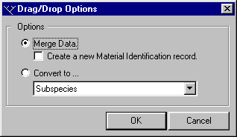
To change the rank of a taxon or to combine taxa, drag the taxon to be changed or merged and drop it onto a taxon of a rank other than the rank of the original parent. A message box will be displayed giving two options: (1) merge the two taxa (and optionally reidentify material belonging to the original taxon) or (2) convert the taxon to a new rank (the available new ranks being listed in a picklist).
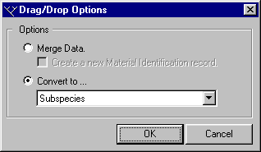
The Merge Data option will transfer information associated with the taxon being dragged to the taxon being dropped onto. Any children will also be transferred to the new taxon. Finally, the name of the dragged taxon will be deleted. If the ‘Create a new Material Identification record’ option is selected, the identification history of all material associated with the taxon being dragged will be updated with the previous identification and its current identification changed to that of the new taxon. If this option is not selected, the identification history will not be changed, although the current identification will still be updated.
Choosing the Convert option will convert the taxon being dragged into the new rank specified in the picklist. All information associated with the taxon will remain, as will any children (including both valid and available names, if present).

Drops that fail
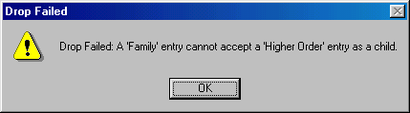
Because of the flexibility of drag and drop, changes can be attempted that would result in inappropriate relationships between taxa. For example, moving a higher order taxon to be a child of a family is not permitted. When these types of operations are attempted a warning will be displayed and the move cancelled. For a list of permitted relationships see Taxon Ranks above.

Deleting levels from the classification
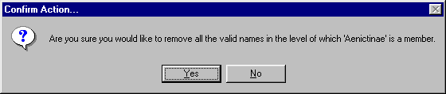
To remove a rank from the classification (for example to remove all subfamilies from a family but leave any genera already present) select a taxon of the rank to be removed, click the right mouse button or open the Edit menu and select the Delete Current Level command. All taxa at the selected rank within the current branch will be deleted, together with all associated data. Any children of the deleted level will be transferred to the parent of the level, and any material identified as belonging to any of the deleted taxa will loose their identifications.
There are restrictions on what can be deleted using this method. This is to ensure that a proper hierarchy and parent-child relationships are maintained. For example, genera can only be deleted if they do not contain species. This is because removing genera with species would result in their species being placed as children of the genera’s parent, usually a family, subfamily or tribe. This would not be acceptable, as species must be placed within a genus and not directly under a family, subfamily or tribe. A warning message will be displayed if an unacceptable deletion is attempted and the delete will be cancelled.

Locating taxon names: the Find tab
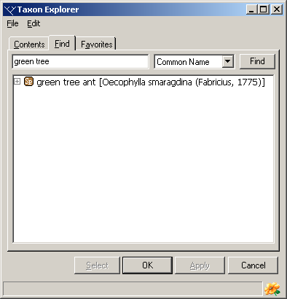
The Find tab on the Explorer can be used to locate taxon names in the database. The drop-down list on the right can be used to select the kinds of names to be searched for. These include all names, scientific names only, common names only, both scientific and common names, and the names of authors.
Enter the required name in the upper box and press the Find button or the Enter key on the keyboard. A list of names matching the request will be displayed in the lower window. To find names containing a subset of characters, enter an asterisk wildcard (*) as the first character or between other characters (a wildcard is automatically added to the end of all requests). For example, to search for names ending with or containing ‘ensis’, such as australiensis, brasiliensis and yorkensis, enter ‘*ensis’ in the Find box. To find just brasiliensis and similar names enter ‘b*ensis.’ Once a search has been completed a taxon can be found in the full list (on the Contents tab) by selecting the name, opening the Edit menu or clicking the right mouse and selecting the Find Entry in Contents command.
If a taxon located using Find contains children, these can be displayed by clicking on the plus symbol before its name (as is done on the Contents tab).

Managing commonly used taxa and sets of taxa: the Favorites tab
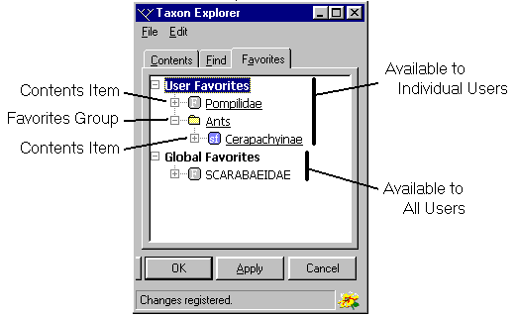
The Favorites tab can be used for easy access to commonly used taxa. The use of Favorites can greatly simplify using the Taxon Explorer, particularly as the size and complexity of a database increases. Copying regularly used taxa to Favorites will reduce the need to search for names and speed access to commonly used information.

Transferring taxa to Favorites
Taxa are transferred to Favorites from the Contents and Find tabs. To transfer a name, select it in Contents or Find and open the Edit menu or click the right mouse button. Select the Transfer Item to Favorites command followed by either the User Specific or Global command. Items transferred in this way will be displayed underlined in Favorites. This distinguishes these items from their children that were not directly transferred. User Specific favorites are only available to the user who was logged on when they were created, while Global favorites are available to all users of the database. Note that Favorites are copies of the items found on the Contents and Find tabs. Any changes made to Favorites, such as adding or deleting taxa or changing relationships, will be saved to the database and will be seen by all users of these items. Thus, the same caution should be used when making changes to Favorites as these will have the same effect as making changes directly on the Contents tab.

Organising Favorites using Favorites Groups
While Favorites can simplify access to taxon names, its use can become less efficient as the number of taxa transferred to Favorites increases. To solve this potential problem, related taxa can be grouped together in Favorite Groups. A Favorite Group can be thought of as a folder that contains a set of Favorites (and possibly other Favorite Groups).
To create a new Favorites Group, select the User Favorites item, Global Favorites item or an existing Favorite Group and click the right mouse button or open the Edit menu and select the Add Favorite Group command. Once created, names can be moved to the Group using drag and drop. Simply drag a taxon name and drop it onto the Group it is to be placed within. Groups themselves can also be organised in a similar way.

Removing items and groups from Favorites
To remove an item from Favorites, select its name and open the Edit menu or click the right mouse button and select the Remove Favorite command. A message will ask to confirm the removal. Note that removing an item from Favorites does not delete it from the database, it only removes it from Favorites and leaves it in Contents. Only items which were transferred directly to Favorites, those that are underlined, can be removed. Children of these Favorites cannot be removed and the Remove Favorite command will not be available if one of these is selected.
To permanently delete an item from Favorites as well as Content (and from the database) select the item, open the Edit menu or click the right mouse button and select the Delete command. A message will ask to confirm the delete. Once deleted, the item will be permanently removed from the database and cannot be retrieved (except from a backup copy of the database).

Controlling access to taxon information
BioLink provides two ways to control access to taxon-based information. The first is through the User Manager where access to the entire Explorer, including all taxon names as well as taxon details, can be controlled. The second method of control is through the Taxon Permissions window. This method sets permissions for individual taxon names and their details.

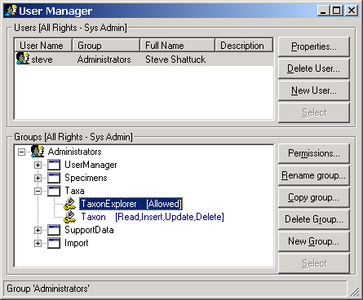
The User Manager
The User Manager can be used to control access to the entire Taxon Explorer and all of its contents. This includes whether or not access is granted to the Explorer, and if granted, whether taxon information can be read, inserted, updated and/or deleted.
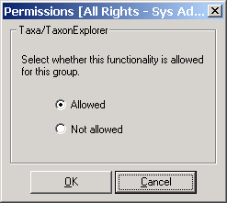
To change these settings, open the User Manager by selecting the User Manager command under the User Manager button on the main BioLink toolbar. Permissions are set individually for each group of users. Select an existing group by selecting it in the list or create a new group by pressing the New Group button and entering its name. Open the details for the selected group by double clicking its name. Expand the Taxa details by double clicking the Taxa item. This will display two items, Taxon Explorer and Taxon. To control access to the entire Taxon Explorer select the Taxon Explorer item and press the Permissions button. This will open the Permissions window. Select Allowed to grant access to the Explorer or Not Allowed to restrict access. If Not Allowed is selected none of the users in the selected Group will be allowed to open the Taxon Explorer.
To control access to items in the Taxon Explorer select the Taxon item in the User Manager window and press the Permissions button. This will open the Permissions window. The following options are available:
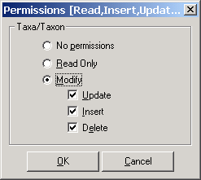
No Permissions: When selected, taxon names in the Explorer can be accessed using the Select button and Drag and Drop but they cannot be modified or deleted. Also, their details are not available.
Read Only: When selected, taxon names and their details are available but they cannot be modified or deleted.
Modify: The option allows partial to complete access to taxa and their information. There are three sub-options: Update allows modification of existing information, Insert allows the addition of new taxa and information and Delete allows the removal of information.
Once the required options have been set press the OK button to save the changes and close the window, and then close the User Manager window.

Taxon Permissions
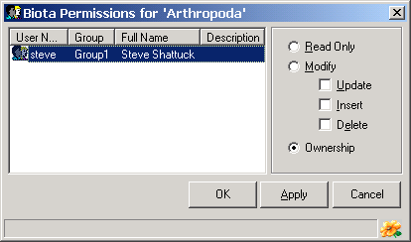
The Taxon Permissions window is used to set access privileges for individual taxa within the Taxon Explorer. These permissions are only available if access to the Explorer is first granted using the User Manager. Setting permissions for individual taxa is important when different users of a BioLink database are responsible for maintaining different taxonomic groups. Access privileges can be set to Read Only or Modify and the Ownership can also be set. To set the level of access, select the taxon of interest, open the Edit menu or click the right mouse button and select the Permissions command. This will open the Taxon Permissions window. This window provides a list of the current users of the database along with the access options. To set access privileges, select a user from the list and set the appropriate options. The available options are as follows:
Read Only: When selected, the taxon (and all of its children) can be viewed but not changed or deleted.
Modify: This allows changes to made to the taxon (and its children). These changes can be set to Update (changing), Insert (adding new taxa) and Delete. When this option is selected the user cannot assign permissions to other users.
Ownership: When selected the user has full access to this taxon (and its children). This user can also give permissions to other users.
Once the required options have been set press the OK or Apply buttons to save changes or the Cancel button to close the window without saving.

Predefined taxon reports
There are a number of predefined reports that relate to taxa. These reports are listed under the Reports command on the Edit menu. To access these reports select a taxon in the Explorer (or several taxa for the Selected Taxa List Report), open the Edit menu or click the right mouse button, select the Reports command followed by the name of the required report. Details of these reports are as follows:

Material for Taxon Report
This report provides a detailed list of material for the selected taxon. It is especially useful in giving a quick overview of holdings for a taxon and in that the underlying data (Sites, Site Visits, Material and Taxa) can be edited directly from the report. Information in the report is formatted in columns and can be quickly reorganised by clicking on the column headings to change the sort order and columns can be reordered using drag and drop.
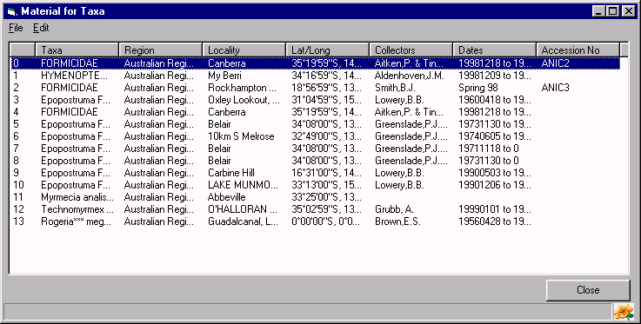
To edit the underlying information in the report, select a row, open the Edit menu or click the right mouse button and select the Edit Site, Edit Site Visit, Edit Material or Edit Taxon command. This will open a Details window with information for the selected item. To export information in the report to disk, select the Export Data command from the Edit menu. This will open the Export Options window. Select the required report type and press the Export button. A window will open where options for the selected export format can be specified. The options available will vary with the format selected.

Sites for Taxon Report
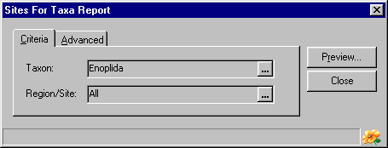
The Sites for Taxon Report provides a text-based report of the collection sites for the currently selected taxon and all of its children. The report is organised by taxon and lists details for each site.
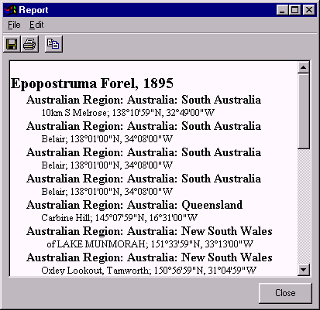
When run, this report opens a dialog box listing the currently selected taxon and (optionally) a geographic region. To change the taxon name or to specify a region, press the Ellipsis button (with the three dots) to the right of the Taxon or Region/Site box. This will open the appropriate Explorer where the taxon name or region can be located and transferred to the dialog box using the Explorer’s Select button or drag and drop. Once these items are properly set, press the Preview button. This will open a window displaying the sites for each taxon in the region.
Information in the report can be copied to the clipboard by selecting the text to be copied and pressing Ctrl+C or using the Copy command from the Edit menu. The entire report can be saved to disk (in RTF: rich text format) by pressing the first toolbar button or selecting the Save As command from the File menu. This will open a Save As dialog box where a file name can be specified. To print the report, press the second toolbar button or select the Print command from the File menu.

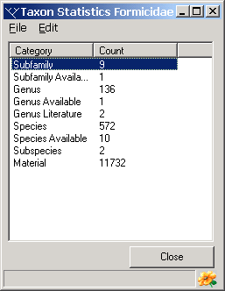
Statistics
The Statistics report provides a count of items in the Taxon Explorer grouped by types. Items include all of the children of the selected Taxon Explorer item and include material records. To sort the information in the report, click on a column heading. This will sort the information alphabetically by that column. Information in the report can be copied to the clipboard using Ctrl+C or the Copy command from the Edit menu. To export information in the report to disk, select the Export command from the Edit menu. Select the required report type and press the Export button. This will open the Export Options window. Select the required report type and press the Export button. This will open a window where options for the selected export format can be specified. The options available will vary with the format selected.

Checklist Report
The Checklist Report provides a text-based report of items in the Taxon Explorer using the current classification. A number of options are available to select the details included in the report, as well as the depth of the classification to display and the taxonomic ranks to include in the report.
Running this report opens a window with a list of display options for the report. These options include the following:
Full Hierarchy: When selected, this option includes the selected Taxon Explorer item and all of its children.
Next Level Down Only: When selected, this option includes the selected Taxon Explorer item and its immediate children only.

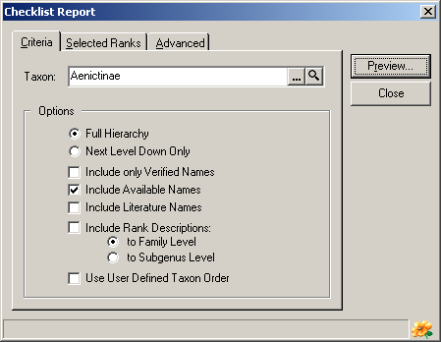
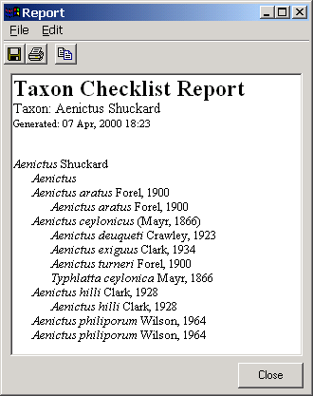
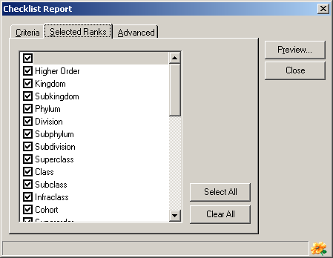
Include only Verified Names: When selected, only names that are verified are included in the report. This will eliminate unverified names from the report.
Include Available Names: Selecting this option will include available names in the report.
Include Literature Names: Selecting this option will include literature names in the report.
Include Rank Descriptions to Family Level: This option will include the rank before the taxon name for taxa at and above the family level.
Use User Defined Taxon Order: When this option is selected the taxa will be displayed in the order specified by the user using the Taxon Explorer’s Sort command.
To restrict the taxonomic ranks included in the Report first click on the Selected Ranks tab and then choose the ranks to be included by clicking the checkbox to the left of the required ranks. Only those ranks selected will be included, the unchecked ranks being skipped.
Once these items are properly set, press the Preview button. This will open a window displaying a checklist for the selected taxon with the selected options.
Information in the report can be copied to the clipboard by selecting the text to be copied and pressing Ctrl+C or using the Copy command from the Edit menu. The entire report can be saved to disk (in RTF: rich text format) by pressing the first toolbar button or selecting the Save As command from the File menu. This will open a Save As dialog box where a file name can be specified. To print the report, press the second toolbar button or select the Print command from the File menu.

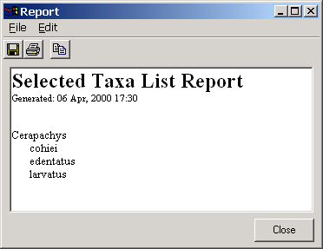
Selected Taxa List Report
The Selected Taxa List Report provides a text-based report of the currently selected Taxon Explorer items. Any number of items can be included in the report and the items do not need to be related. By holding down the control key and clicking items with the mouse, any number of individual items can be selected. These selected items can then be included in the report. When run, this report opens a window containing a list of the selected taxa. This information can be copied to the clipboard by selecting the text to be copied and pressing Ctrl+C or using the Copy command from the Edit menu. The entire report can be saved to disk (in RTF: rich text format) by pressing the first toolbar button or selecting the Save As command from the File menu. This will open a Save As dialog box where a file name can be specified. To print the report press the second toolbar button or select the Print command from the File menu.

Taxon Explorer commands

File menu
Save/Apply: This command saves any changes made in the Explorer to the database. It is equivalent to pressing the Apply button near the bottom of the Explorer. If the Explorer is closed without first saving changes, these changes will be lost.
Close: Selecting the Close command will close the Taxon Explorer window without saving unsaved changes.

Edit menu
Taxa Properties…: This command allows editing of taxon name details. It should be used to ensure taxon names and their authors and dates of publication have been interpreted correctly. It can also be used to set the rank of Higher Order names, indicate a changed combination for species names and set the ‘Details are Verified’ flag.
Add Taxon: The Add Taxon command is used to add new taxon names to the Explorer. Selecting this command opens a submenu that contains a list of the names that can be added. This list will vary with the type of Explorer item selected when the command is called. For example, if a family name is selected, the submenu will contain the following options: Subfamily, Genus, Family Available Name, Literature Name, Unranked Valid, Species Inquirenda, Incertae Sedis, Unplaced Subfamily and Unplaced Genus. Selecting one of the items from this submenu will add a blank name to the Explorer as a child of the name selected when the Add Taxon command was selected.
Change Rank: This command allows the rank of an Explorer item to be changed. The available ranks include Unranked as well as those ranks which do not violate the rules governing the hierarchy.
Delete: This command is used to delete the currently selected taxon from the Explorer. It has the same effect as pressing the Delete key on the keyboard. Deleting a taxon also deletes all information associated with that name. Any material identified as belonging to the deleted name will lose their current identification and will therefore becomes unidentified. Deletions will become permanent when the Explorer’s OK or Apply buttons are pressed, or the Save/Apply command is selected from the File menu. Deletions can be abandoned by pressing the Cancel button.
Delete Current Level: This command deletes the selected taxonomic level from the displayed branch of the Explorer. For example, it can be used to remove subfamilies from a family and automatically move any genera to be children of the family. There are restrictions on what can be deleted using this command. For example, deletions that would result in inappropriate parent-child relationships or an unacceptable hierarchy will not be permitted.
Rename: This command is used to change the name of a taxon. After selecting this command, the existing name can be modified or replaced as required. Pressing the Enter key will save any changes made to the name.
Add Favorite Group: This command adds a Favorite Group to the list on the Favorites tab. These groups can be used to organise taxa copied to Favorites. This command is only available when the Favorites tab is open.
Add Item to Favorites: This command is used to transfer names from Contents and Find to Favorites. There are two options on a submenu, User Specific and Global, which transfer the name to the Favorites of the currently logged on user or to the Favorites available to all users, respectively.
Remove Favorite: This command removes the selected item from Favorites. Only items that where transferred to Favorites, those that are underlined, can be removed.
Add Specimen: This command opens the Rapid Data Entry window where specimen details can be added. See Chapter 4, Working with Material for further details.
Sort: The order names are displayed within the Explorer is controlled using this command. There are two options (selected from a submenu): By Name, which sorts names alphabetically, and By Manual Order, which sorts names by a previously specified, user-defined order. Names can be switched between these two ordering systems at any time without losing information on the other order.
Increase in Order: This command is available when the By Manual Order command is active. It is used to move the selected name downward relative to other taxa of the same rank within a branch.
Decrease in Order: This command is available when the By Manual Order command is active. It is used to move the selected name upward relative to other taxa of the same rank within a branch.
Expand Full Branch: The Expand Full Branch command is used to quickly display all children of a selected taxon. It is equivalent to successively clicking the plus symbol in front of all names belonging to a given taxon. Note that this command should be used with caution when working with large datasets. Expanding a higher order taxon containing several thousand species (with several thousand available names) can be quite time consuming and this command cannot be aborted once started.
Find Entry in Contents: This command is only available from Find and Favorites. It is used to locate a given name in the full classification found in Contents. This is necessary since Find and Favorites will often show only a small section of the complete classification and it may be desirable to place a taxon in the broader context of the complete classification.
Reports: The Report command opens a submenu containing several predefined reports.
Distribution Map…: This command opens the Mapping Assistant and displays all geocoded material records for the selected Explorer item(s). If multiple items are selected in the Explorer, all records for all items will be displayed with each taxon on a separate layer. See Mapping Assistant for information on the use of this tool.
Material for Taxa List…: This command opens the Material for Taxa report, which gives details of material identified as belonging to the selected taxon. See Predefined Reports for additional information.
Site by Taxa Report…: This command opens the Site by Taxa report, which gives details of all sites where the selected taxon is known to occur. See Predefined Reports for additional information.

